Assignment 10.4

1.Write a pig script find the average age of male and female persons died in the titanic tragedy .

A = LOAD ‘/home/acadgild/TitanicData.txt’ USING PigStorage (‘,’) AS (passengerId:int, survived:int, pclass:int, name:chararray, sex=chararray, age:int, sibSp:int, parch:int, ticket:chararray, fare:chararray,cabin:chararray,embarked:chararray);

B = FILTER A by survived==1;

C = GROUP B by sex;

D = FOREACH C generate group, AVG(B.age);

DUMP D;

OUTPUT :

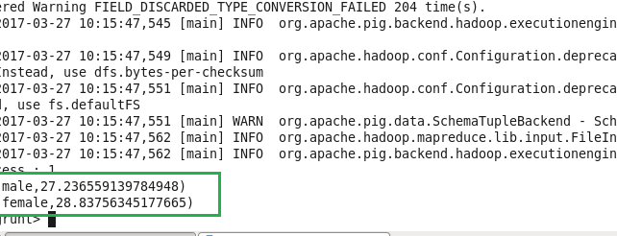

2.Write a pig script to find the number of people died and survived in each class

A = LOAD ‘/home/acadgild/TitanicData.txt’ USING PigStorage (‘,’) AS (passengerId:int, survived:int, pclass:int, name:chararray, sex=chararray, age:int, sibSp:int, parch:int, ticket:chararray, fare:chararray,cabin:chararray,embarked:chararray);

B = GROUP A by (pclass,survived);

C = FOREACH B generate group, COUNT(A.passengerId);

DUMP C;

OUTPUT :

